Roomify
Technical Report
Problem, approach, system design, models, results, limitations and future work
Team Bootcamp2Roomify
Release v1.0.0 (demo mode)
24 October 2026

Redesign more, buy less. Devpost: https://devpost.com/software/roomify-hsc4yn · Code: backend · CV service · frontend
Release v1.0.0 (2026-10-26). Everything below is implemented, merged and tested. The OpenAI account was unusable at submission (one key rejected with 401, the other out of credit with 429), so the submitted build runs in demo mode: AI features return pre-generated results from a bundled demo library, clearly labelled "Demo" in the app. AI quality, latency, cost and budget-compliance results (§6.2) are therefore Demo mode (pre-generated results) — no model numbers are reported or estimated.

1. Problem
People who most want to improve their room — students, renters, young adults on small budgets — are the least served by existing tools (scope):
- They can't picture a redesign in their own room. Inspiration sites show other people's spaces.
- They can't see the total cost, or what to cut when a plan is over budget.
- They often can't drill, paint or replace flooring, yet most ideas assume they can.
- Usable furniture gets replaced instead of kept, moved, repaired or upcycled.

2. Approach
One photo of the real room becomes one organised, saved project:
- Detect the major furniture in the photo (computer vision).
- Let the person correct and decide: Keep, Replace, Remove or Unsure per item; rename, remove or add items the detector got wrong. Detection is treated as a draft, not ground truth.
- Collect constraints: style, colours, room purpose, maximum budget, Rental-Friendly Mode (on by default for renters and dorms), free-text requirements.
- Generate a plan with an LLM, then verify it in code: every kept item is kept, every removed item removed, the costs add up and fit the budget, rental mode contains no permanent work. A plan that breaks a rule is retried once with the reason, otherwise rejected — never shown.
- Render a visual concept by editing the person's own photo with an image model, guided by the verified plan.
- Suggest purchases and DIY within the budget: estimated price, placement, reason, a cheaper alternative, and beginner DIY guides that pass a safety filter.
- Save everything under the person's account; the dashboard reopens any project where it stopped.
The design principle is the model proposes, the server disposes: LLM output is untrusted input that must pass deterministic validation before it is stored.

3. System design
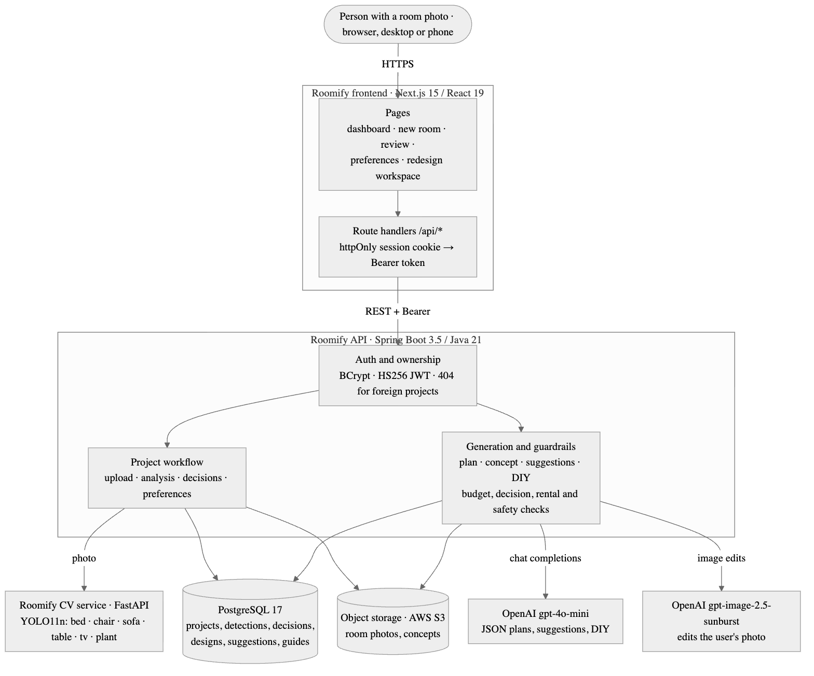
Figure 1. Roomify system architecture.
Service | Stack | Responsibility
Frontend | Next.js 15.5, React 19, TypeScript, Tailwind | Pages; a same-origin bridge (/api/* route handlers) that keeps the JWT in an httpOnly cookie and forwards it as a Bearer token
Backend | Spring Boot 3.5, Java 21, PostgreSQL 17 + Flyway | Auth and ownership, workflow state, storage, provider calls, all validation
CV service | FastAPI, Ultralytics YOLO11n | Furniture detection; private, called only by the backend
Storage | AWS S3 (or local disk) | Room photos and generated concepts
AI | OpenAI | Plans, suggestions, DIY (text); concept image (image edits)

3.1 Data flow
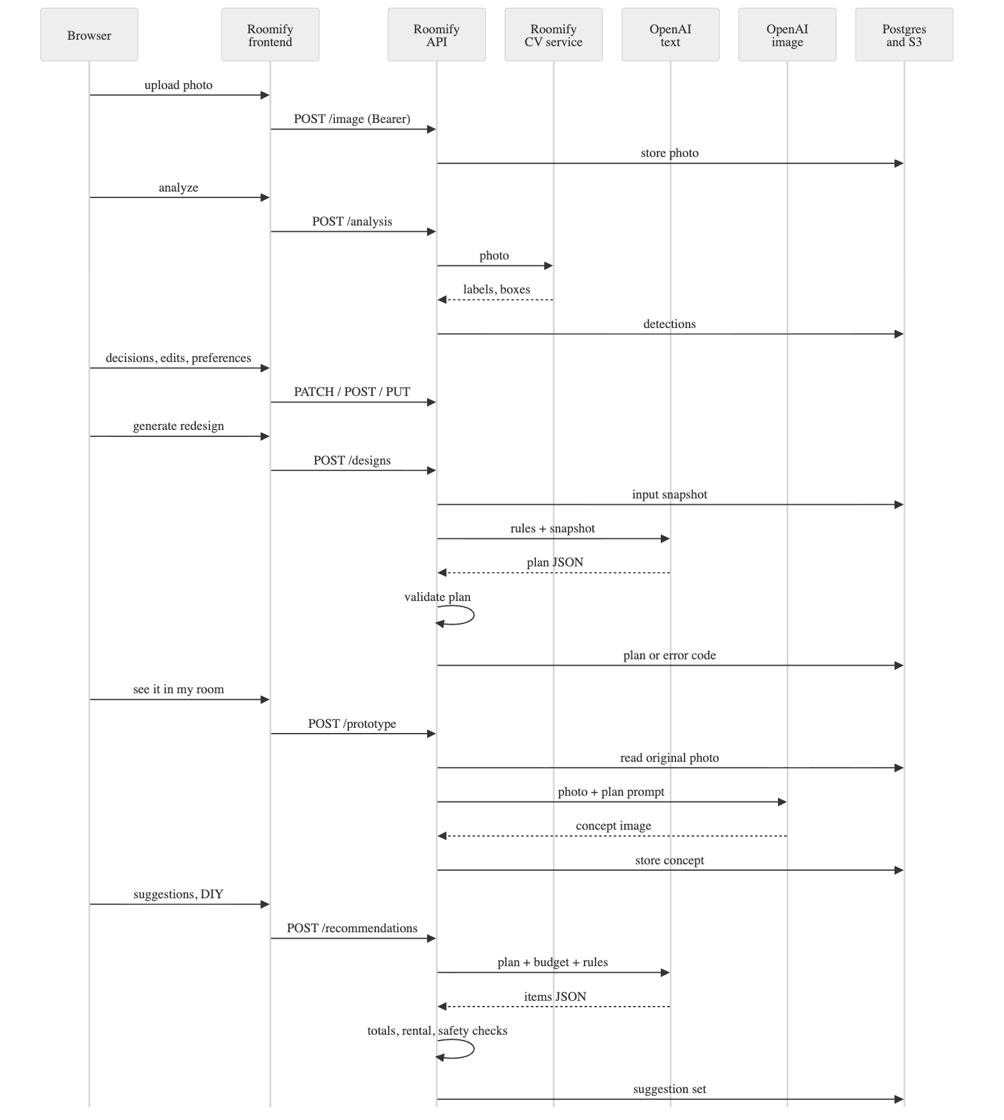
Figure 2. Roomify request flow from upload to plan, visual concept and suggestions.

3.2 Data model (main tables)
users → room_projects (owner, name, room type, rental status, workflow status) → room_images → detected_objects (stable UUID, source CV/MANUAL, active flag) → furniture_decisions; project_preferences; design_requests (immutable input snapshot, provider, prompt version) → design_results (plan JSON, status, error code) → design_assets (concept image); recommendation_sets → recommendation_items → recommendation_diy_guides. Ten Flyway migrations.

4. Models and providers
Task | Model | Why | Settings
Furniture detection | Ultralytics YOLO11n, COCO-pretrained | Runs on CPU in ~32 ms, 5 MB, no training needed | confidence ≥ 0.25; six classes kept: bed, chair, sofa, table, tv, plant
Plan, suggestions, DIY | OpenAI gpt-4o-mini (Chat Completions, json_object) | Cheapest model that follows long JSON schemas | temperature 0.1, ≤ 4000 output tokens, 1 corrective retry
Visual concept | OpenAI gpt-image-2.5-sunburst (images/edits) | Edits the user's real photo; OpenAI's replacement for the retired gpt-image-1, positioned for precise edits (not yet called live) | 1024×1024, quality low
Model names are configuration. Two provider facts discovered during the build changed the defaults: gpt-image-1 was shut down by OpenAI on 2026-10-23, and gpt-4o-mini shuts down on 2027-01-14 (its replacement gpt-6-luna is a reasoning model; the request code now supports it by configuration).

5. Key decisions
- Detection is a draft. COCO has no desk, wardrobe, shelf or lamp class, and measured recall is 0.62 (§6.1). So the review step supports rename, remove and add, low-confidence items are flagged, and analysis failure offers manual entry instead of a dead end.
- Validate generated output in code. Plans must contain every detected item exactly once with its saved decision; instructions must match the decision ("Keep …", "Replace …"); allocations must sum exactly to the total and fit the budget (BigDecimal); rental plans are scanned for permanent work; low-confidence and Unsure items need uncertainty wording. Suggestions get server-computed totals and strictly-cheaper alternatives; DIY guides are Beginner/Easy, cheaper than buying, and rejected if they mention electrical, plumbing, gas or structural work.
- Immutable input snapshots. Each generation stores exactly what the model saw (detections, decisions, preferences, image reference). The concept is rendered from the snapshot's photo, so it always matches its plan, and a design whose inputs changed mid-generation is rejected.
- Privacy by construction. One authorization rule covers every /api/projects/{id}/** route; another user's project is indistinguishable from a missing one (404). The browser never holds the JWT. The CV service is designed to stay off the public internet, and its image_url input refuses non-public addresses (SSRF).
- Estimates, said plainly. Prices, totals and the concept image are labelled as estimates and concepts everywhere they appear; the plan page states it is not a professional plan.
- Budget warnings that stay true. Stored suggestions always fit the budget at generation time; if the person lowers the budget later, the summary warns and shows what switching to the cheaper options would save.

6. Results

6.1 Detection (measured)
60 COCO val2017 indoor images (held out from training), 159 objects, matched at IoU ≥ 0.5 through the product's HTTP API. Full table, method and failure cases: Evaluation Evidence.
 | Precision | Recall | Recall, large objects
All six classes | 0.70 | 0.62 | 0.68
Best (bed) | 0.86 | 0.74 | 0.73
Worst (table) | 0.40 | 0.55 | 0.67
Latency: 32 ms p50 / 41 ms p95 model time on a laptop CPU.

6.2 Generation
Result | Value
Plan budget compliance | Demo mode (pre-generated results)
Plan decision and rental compliance | Demo mode (pre-generated results)
Suggestions within budget | Demo mode (pre-generated results)
DIY safety-filter rejections | Demo mode (pre-generated results)
Latency per AI step | Demo mode (pre-generated results)
Cost per redesign | Demo mode (pre-generated results)
Method and demo-mode behaviour: Evaluation Evidence §2. Demo results pass the same validators as model output (plan budget and decisions, suggestion budget, DIY safety and rental rules) and are marked source: "demo". Verified with fallback off and no key: every AI action fails with a clear AI_CONFIGURATION_ERROR message and leaves the project usable (Evaluation Evidence §3).

6.3 Engineering quality
Suite | Result (develop, 2026-10-26)
Backend JUnit (Postgres 17) | 183 passed
CV pytest | 21 passed
Frontend Vitest | 233 passed
Playwright, stubbed API, chromium + mobile | 39 passed
Playwright, fake Spring API through Next | 6 passed
Playwright, real stack, demo mode | full journey incl. all AI steps, privacy, logout, CV-down fallback passed
CI runs on every push and PR in all three repositories. Secret scan of all history (including unreachable objects): no secrets.

7. Limitations
- Detection misses about a third of objects, most of them small; it cannot detect desks, wardrobes, shelves, lamps or rugs at all (COCO classes). Measured on 60 COCO images, not on user photos.
- No spatial understanding. One photo gives no scale; the plan never claims dimensions or fit.
- Concepts are not photos. The image model may change proportions, windows or lighting and does not reproduce kept furniture exactly.
- Prices are model estimates, not retailer data; there is no live shopping API.
- Rental and safety checks are keyword-based and cannot certify a lease or a DIY step as safe.
- One room, one photo per project (as scoped).
- Provider dependence. Two of three models changed status during the build; defaults may need updating again. The text model's deprecation date (2027-01-14) is documented.
- AI features unverified live. Plan, concept, suggestion and DIY generation have only run against fake providers; the default image model (gpt-image-2.5-sunburst) has never been called.

8. Future work
- Fine-tune a detector on interior datasets with desk, wardrobe, shelf, lamp and rug classes.
- Multiple photos per room for better coverage; optional measurements for fit checks.
- Real product search with live prices and second-hand listings.
- Before/after slider, several concept variations, and a follow-up chat ("make it cosier", "cut cost").
- Run generation asynchronously with progress updates instead of one long request.

